**Ex No:9**

**Date:**

**IMPLEMENT CODE OPTIMIZATION TECHNIQUES CONSTANT FOLDING**

**AIM:**

To write a C program to implement Constant Folding (Code optimization Technique).

**ALGORITHM:**

* The desired header files are declared.
* The two file pointers are initialized one for reading the C program from the file and one for writing the converted program with constant folding.
* The file is read and checked if there are any digits or operands present.
* If there is, then the evaluations are to be computed in switch case and stored.
* Copy the stored data to another file.
* Print the copied data file.

**PROGRAM**:

#include <stdio.h>

#include <string.h>

#include <ctype.h>

void main() {

char s[20];

char flag[20] = "//Constant";

char result, equal, operator;

double op1, op2, interrslt;

int a, flag2 = 0;

FILE *fp1, *fp2;

fp1 = fopen("input.txt", "r");

fp2 = fopen("output.txt", "w");

fscanf(fp1, "%s", s);

while (!feof(fp1)) {

if (strcmp(s, flag) == 0) {

flag2 = 1;

}

if (flag2 == 1) {

fscanf(fp1, "%s", s);

result = s[0];

equal = s[1];

if (isdigit(s[2]) && isdigit(s[4])) {

if (s[3] == '+' || s[3] == '-' || s[3] == '*' || s[3] == '/') {

operator = s[3];

op1 = s[2] - '0';

op2 = s[4] - '0';

switch (operator) {

case '+':

interrslt = op1 + op2;

break;

case '-':

interrslt = op1 - op2;

break;

case '*':

interrslt = op1 * op2;

break;

case '/':

if (op2 != 0)

interrslt = op1 / op2;

else {

fprintf(fp2, "Division by zero error.\n");

fclose(fp1);

fclose(fp2);

return;

}

break;

default:

interrslt = 0;

break;

}

fprintf(fp2, "/*Constant Folding*/\n");

fprintf(fp2, "%c = %.2lf\n", result, interrslt);

flag2 = 0;

}

} else {

fprintf(fp2, "Not Optimized\n");

fprintf(fp2, "%s\n", s);

}

} else {

fprintf(fp2, "%s\n", s);

}

fscanf(fp1, "%s", s);

}

fclose(fp1);

fclose(fp2);

}

**OUTPUT:**

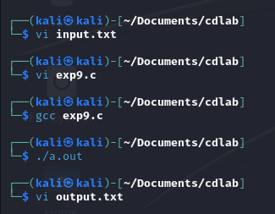

**Input.txt:**

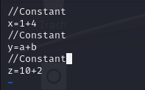

**Output.txt:**

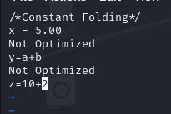

**RESULT:**

Thus, a C program to implement Constant Folding has been developed.